实验6Jupiter的安装及Review ID的创建及发布

|  |  |  |  |  |  |  |  |
| --- | --- | --- | --- | --- | --- | --- | --- |
| 组 别 |  | 实验人员 | KAFLE SAMRAT | | | | |
| 实验项目名称 | Jupiter的安装及Review ID的创建及发布 | | | | | | |
| 实 验 类 别 | 验证型□ 设计型□ 综合型□ | | | | | | |
| 实 验 工 具 | Eclipse | | | 实验地点 | J13-132 | 实验日期 | 2020.12.16 |
| 学生实验小结 | Jupiter Review 是eclipse中的一个测试代码的工具，通过个人测试，小组复议，最后的解决办法解决问题，最后保存下来的情况可以保存在VisualSVN Server中。该工具可以将测试的情况保存在本地服务器中或者将服务器中的资源拉取下来，类似于github、gitee等 | | | | | | |
| 教师评语 | 指导教师签名：  年 月 日 | | | | | | |
| 实验成绩 |  | | | | | | |

1实验内容和目标

1.1实验内容

学习在Eclipse中在线安装插件（本实验中指Jupiter）。安装的Jupiter插件用于之后的代码审查工作，本实验完成Review ID的创建及发布。

1.2实验目标

1. 掌握安装Eclipse插件Jupiter的方法；
2. 掌握代码审查任务Review ID的创建及发布方法。

2实验方案设计

2.1实验环境

Eclipse+jdk1.8

2.2实验方法设计

选择的测试方法和设计的测试用例，自己编写的测试代码等。

使用jupiter对代码进行测试，首先安装jupiter然后使用review发布Review ID

3实验步骤和结果

Installation of the Eclipse plug-in

Offline installation and use of the teacher to edu.hawaii.ics.csdl.jupiter_4.0.0 folder, paste into the plugins directory path of the eclipse.

Click on Properties of the project in ECLPISE to find that Review already exists, indicating that the plug-in has been installed successfully

3.2.Review ID creation and publication

First, right-click the project you want to review in the "Project Explorer" list, then select "Properties", "Review".

Click "New..." Edit "Review ID" and its "Description" in the pop-up dialog box, as shown in Figure 4. After the edit is completed, proceed to the next step.

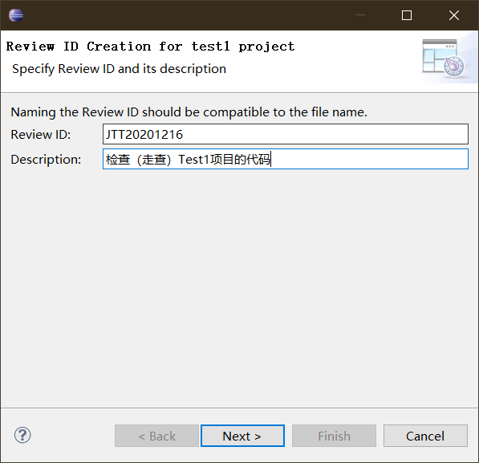

Select the file to review (multiple files can be selected at the same time), and when the selection is complete, proceed to the next step.

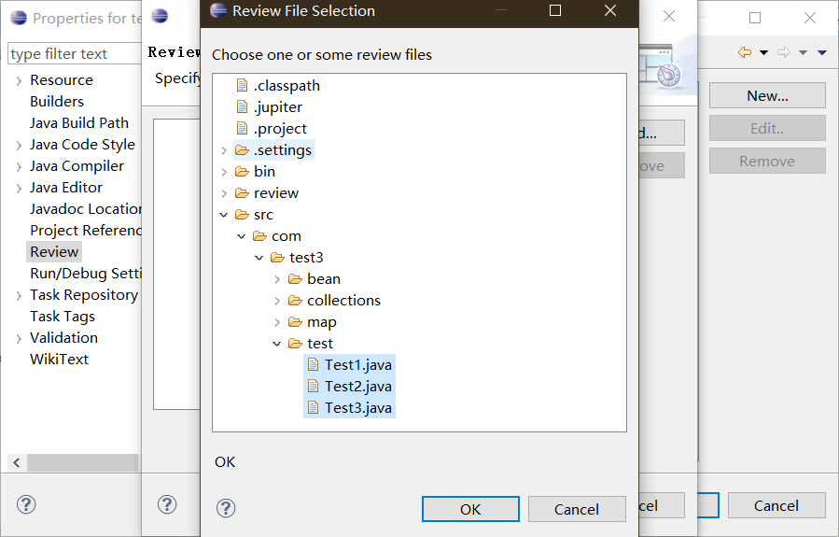

Select the Review Lead (Author of This Review Session) from the added people and proceed to the next step.

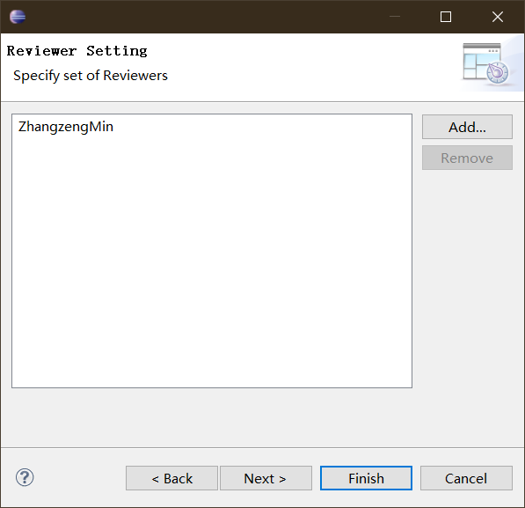

The types of "Type", "Severity", "Resolution" and "Status" can be set according to the needs or requirements of the project (the types can be deleted or added), and then the default types of the above four items can be set in the next step.

Set. Review file to be stored directory name (Storage Directory), set the completion of the next step.

Set filters for three phases (individual review, team review, and problem fix). Use the default filter for the first two phases (in the "Rework Phase", if you want developers to see all types of bugs (Open, Resolved, Closed, Reopened), leave the check box before "Where Status is:" unchecked and click "Finish" to complete the creation of Review ID

Review ID publishing

After the Review ID is created, a ".jupiter "file (as shown in Figure 7) is created in the project's file directory and published to a version control system such as SVN or CVS, or published by mail, etc

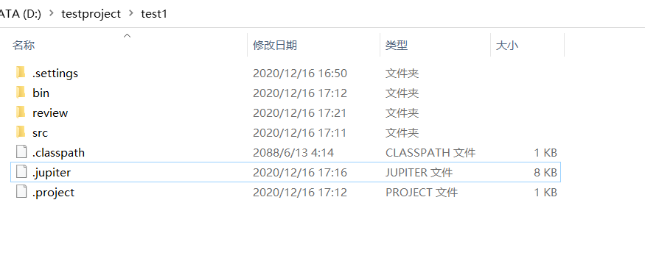

Open VisualSVN Server to establish the version library JupiterTest1, and configure the permissions, etc

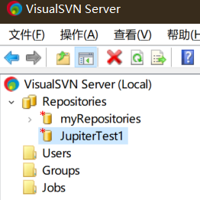

Create user set user password

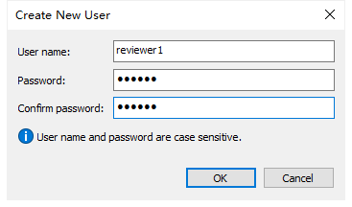

In the location of my test code, there is the.jupiter file directory as the location to download the code. Right click SVN and check it out

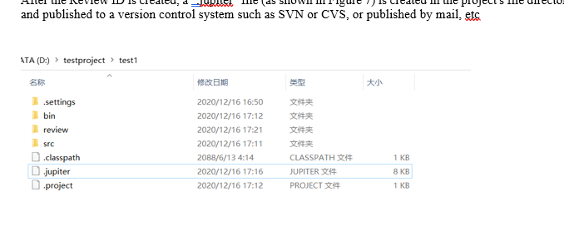

After exporting, copy the generated.jupiter file to that folder, right-click and select Submit, and the file is now in the SVN server

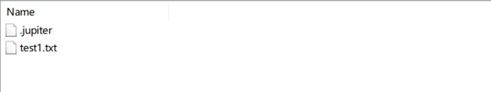

Right-click the resource library to obtain the resource library URL, to the browser can be viewed



实验结果分析

使用新版的eclipse发现离线方法无法成功创建插件，使用旧版才可，从设置Review我发现代码审查是非常正式化地一系列操作，包括设置项目的审查代码内容，以及审查人的姓名等等，保存在一个.jupiter文件中，供后期审查人员的使用，是一个思路清晰的方法。